Order Of Service

Singing: Psalm 89—CW page 98

Reading: Psalm 8

Opening Hymn: TLH 629

Reading: I Corinthians 7:17-24

Request Hymn: CW Supplement 749

Reading: Matthew 27:24-31

Sermon Hymn: TLH 23

Sermon Text: Luke 9:37-42

Down From The Mountain Top

Prayer

The Apostles’ Creed, TLH page 12

Holy Communion

The Lord's Prayer

The Blessing

Closing Hymn: TLH 43

* * * * * * * * * * *
Bible Study: Lambs: Arctic Lemming
Sheep: Philippians 1:1-11


Fall Scene On Lake Superior

Water
Of
Life
10 October 202
W A T E R O F L I F E

Independent Christian Church—Conservative Lutheran Doctrine

Worship Service: 9:30 a.m. Bible Study: 10:45 a.m.

Larry Cooper, Pastor E-Mail address:
111 N. Ridge Road lcooper@wateroflife.cc
Coon Valley, WI 54623 Web Site:
www.wateroflife.cc

* * * * * * * * * * * * * * * * * * * * * * * * * * *

Sermon Text: Luke 9:37-42

Down From The Mountain Top

* * * * * * * * * * * * * * * * * * * * * * * * * * *

37 And it came to pass, that on the next day, when they were come down from the hill, much people met him.
38 And, behold, a man of the company cried out, saying, Master, I beseech thee, look upon my son: for he is mine only child.
39 And, lo, a spirit taketh him, and he suddenly crieth out; and it teareth him that he foameth again, and bruising him hardly departeth from him.
40 And I besought thy disciples to cast him out; and they could not.
41 And Jesus answering said, O faithless and perverse generation, how long shall I be with you, and suffer you? Bring thy son hither.
42 And as he was yet a coming, the devil threw him down, and tare him. And Jesus rebuked the unclean spirit, and healed the child, and delivered him again to his father.

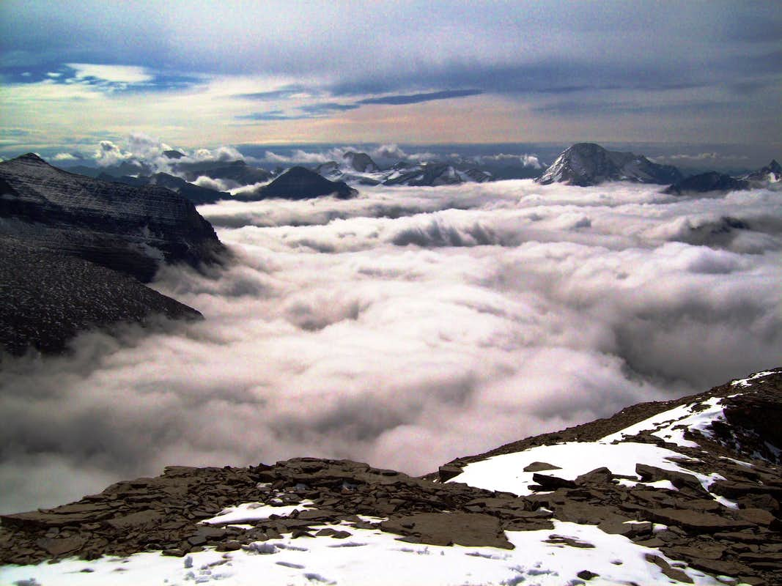

Down From The Mountain Topu

